**PROJECT DEVELOPMENT PHASE**

**Delivery of Sprint - 1**

|  |  |
| --- | --- |
| Team ID | PNT2022TMID18706 |
| Project Name | VISUALIZING AND PREDICTING HEART DISEASEWITH AN INTERACTIVE DASH BOARD. |

# Fetch data from external API (Kaggle API)

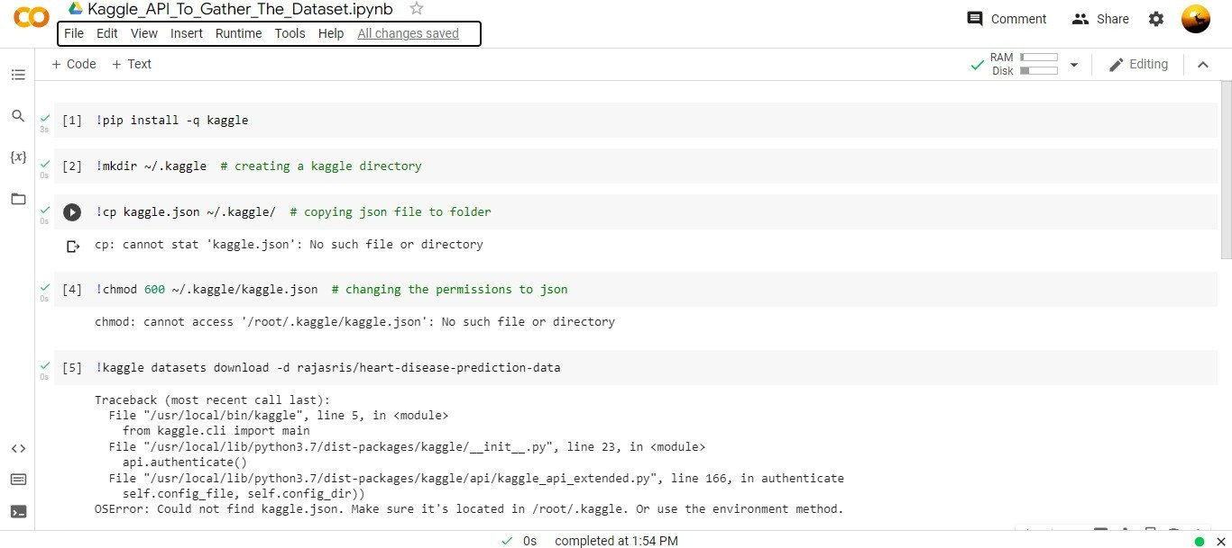

**IBM DB2 service creation and DB2 connectivity with cognos:**

Step 1: In cognos we have to perform data server connections.

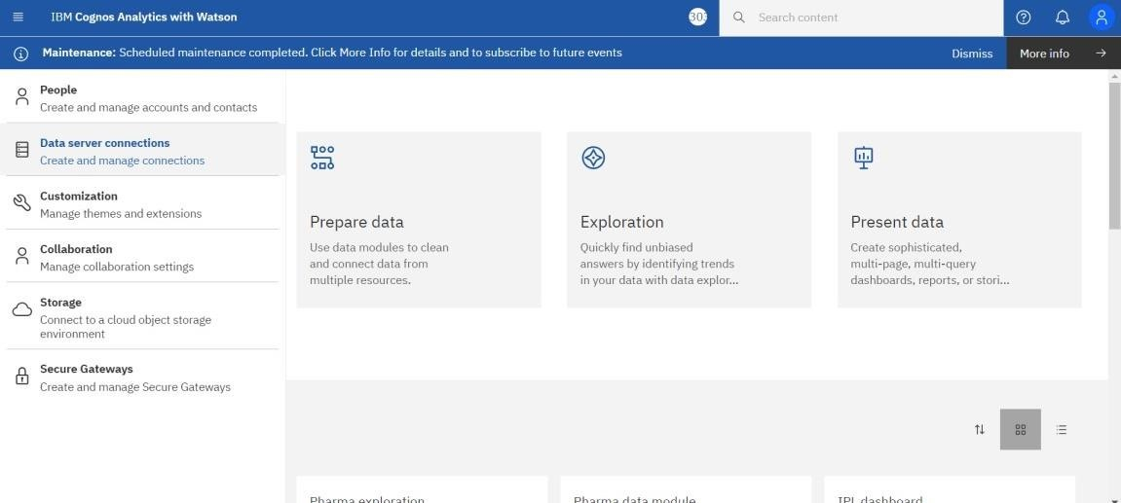

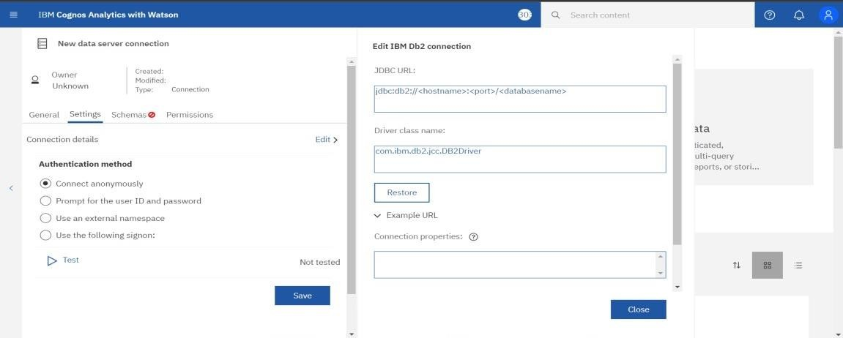

**STEP 3:** In IBM cloud go to catalog and search for db2.

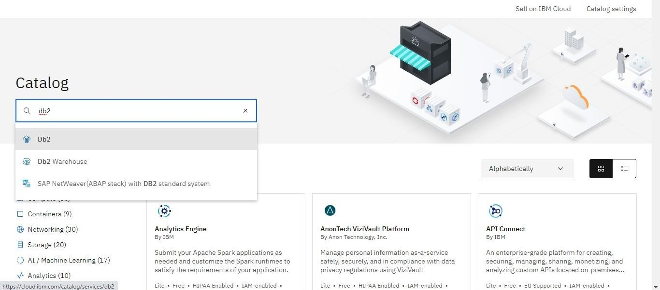

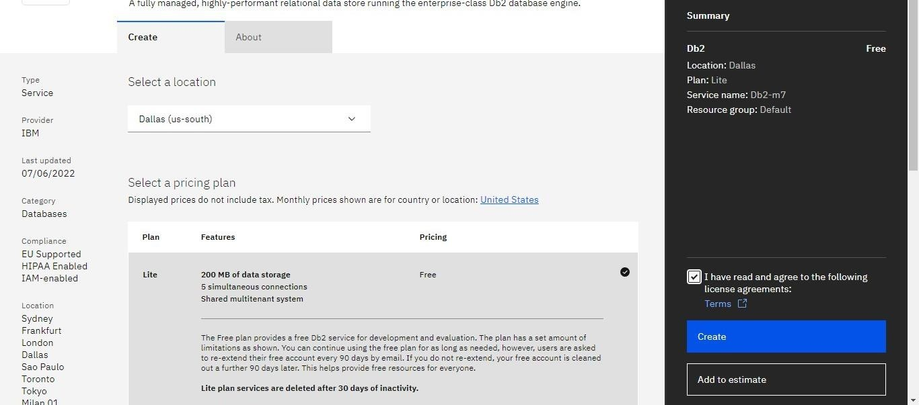

**STEP 5:** From the resource list select database as Db2.

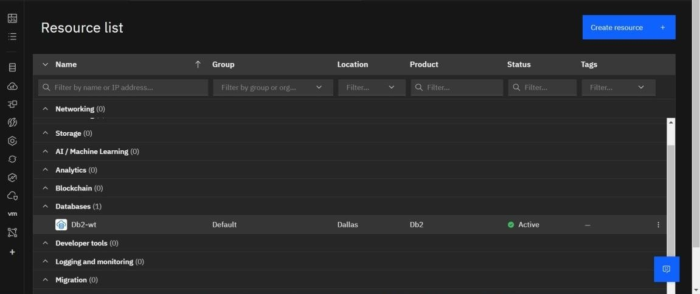

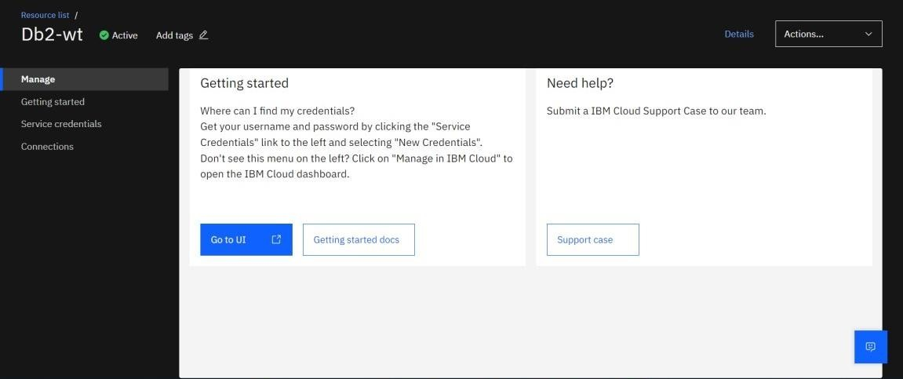

**STEP 7:** Resource usage of IBM Db2 on cloud.

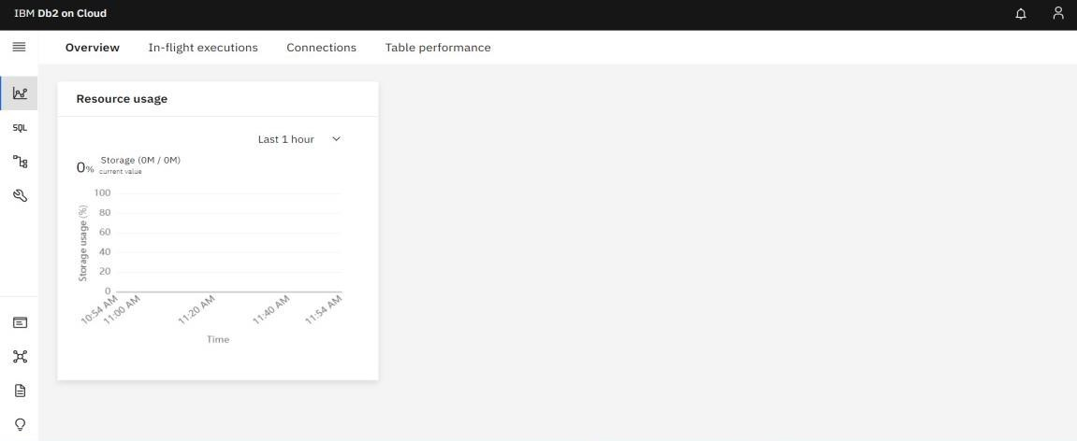

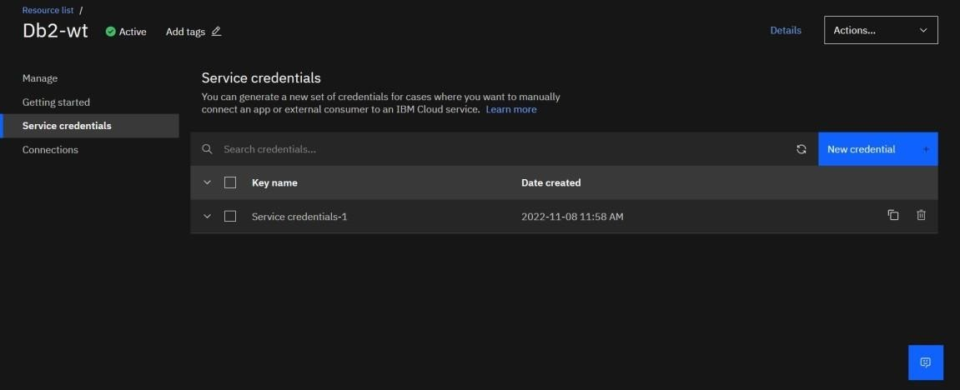

**STEP 9:** Copy the JDBC url from the created service credential in IBMCloud.

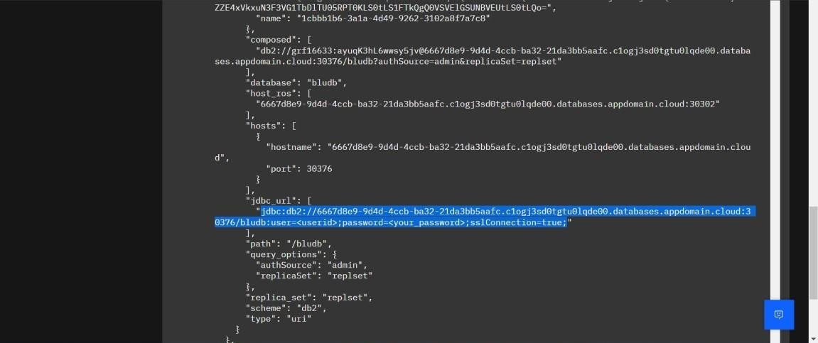

creating data server connection.

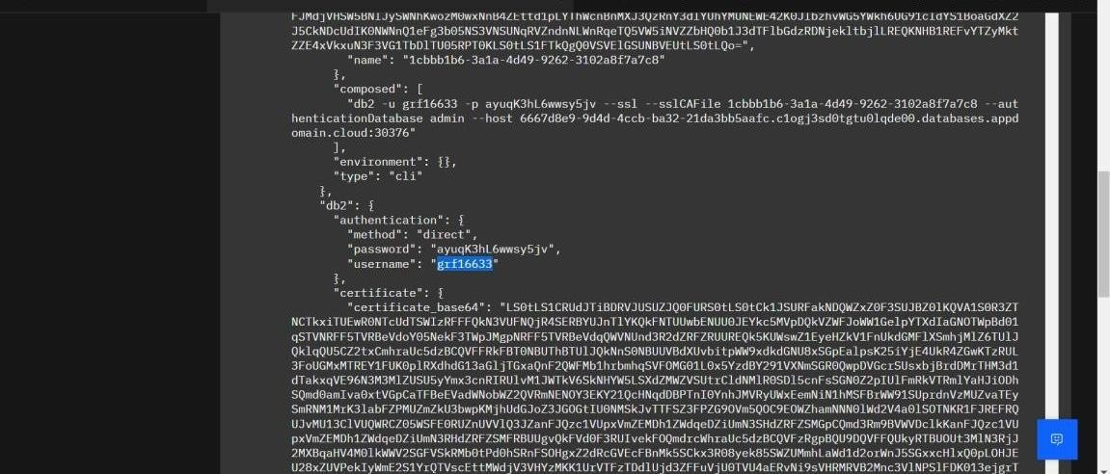

**STEP 10:** Copy the password and paste it in JDBC url in cognos.

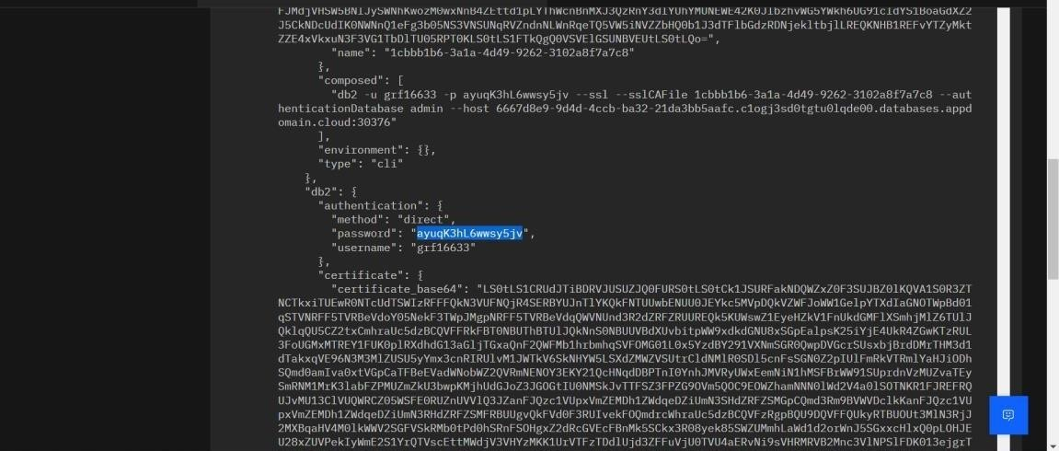

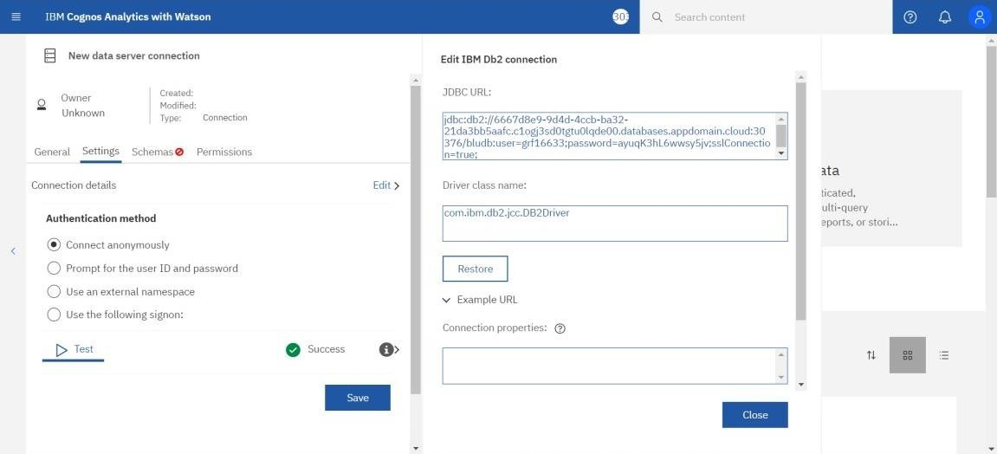

**STEP 12:** In IBM Db2 Select a schema and create a table.

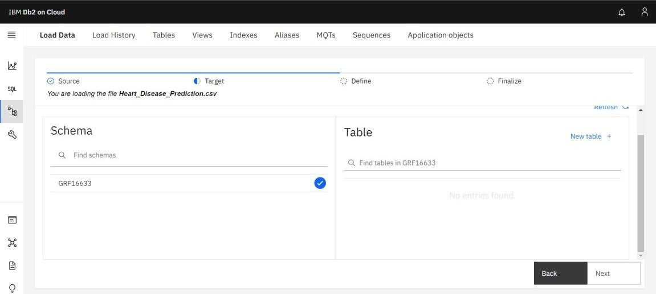

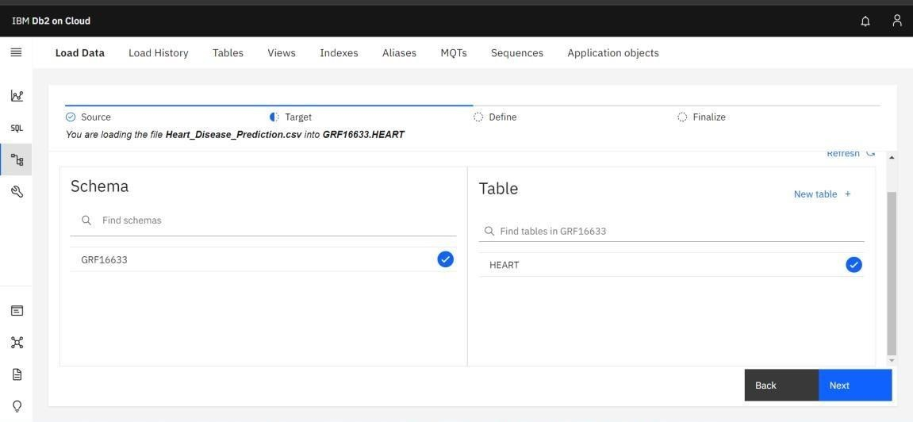

**STEP 14:** The creation of table is shown below:

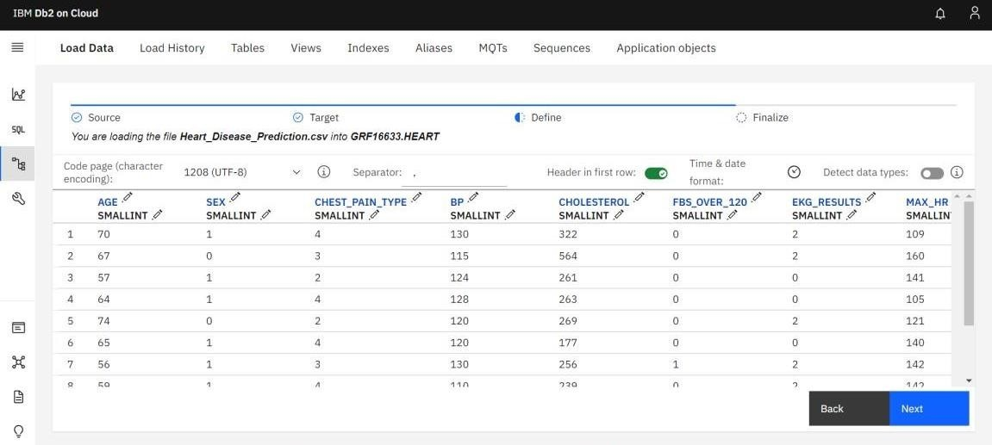

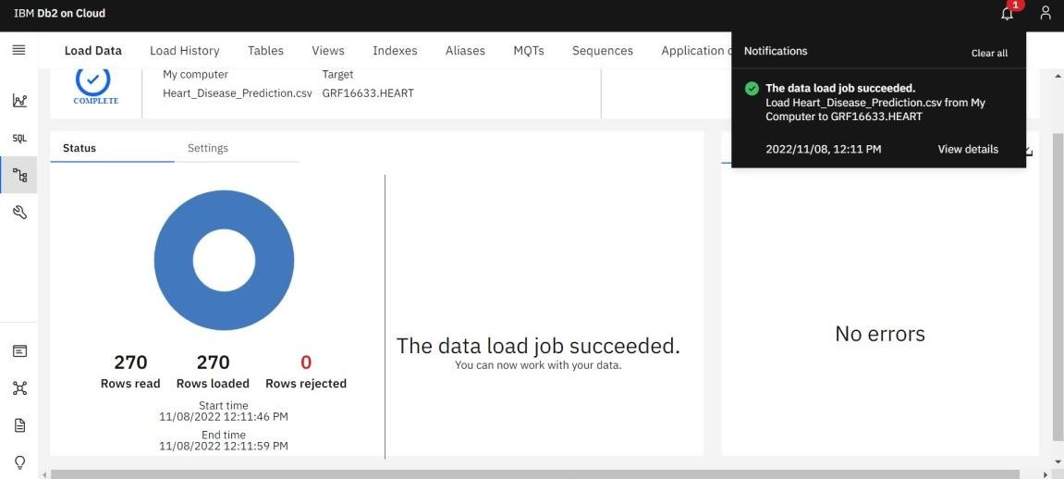

**STEP 16:** The below table represents the data present in our Dataset.

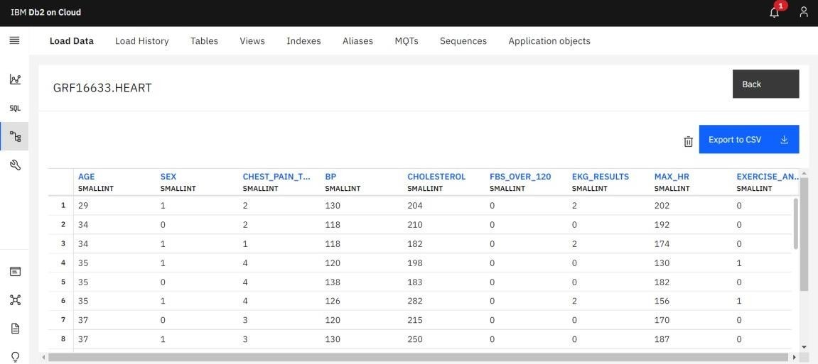

**STEP 17:** Loading of metadata and successfully loaded data in cognos by server connection.

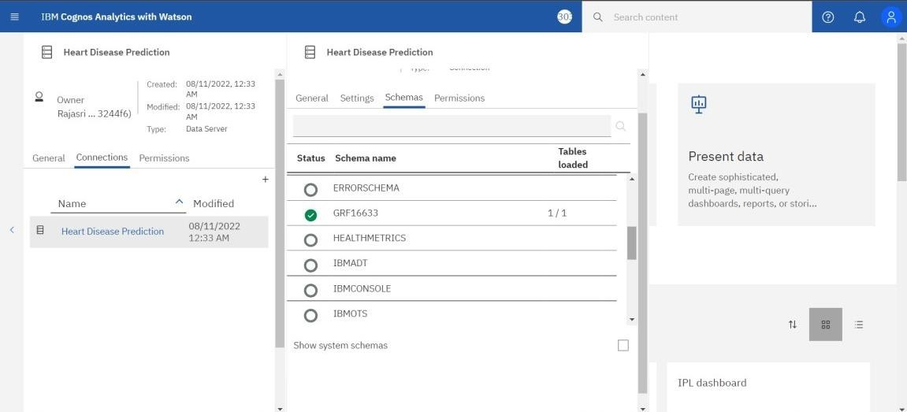

# Creation of Data Module:

**STEP 1:** Creation of Data Module.

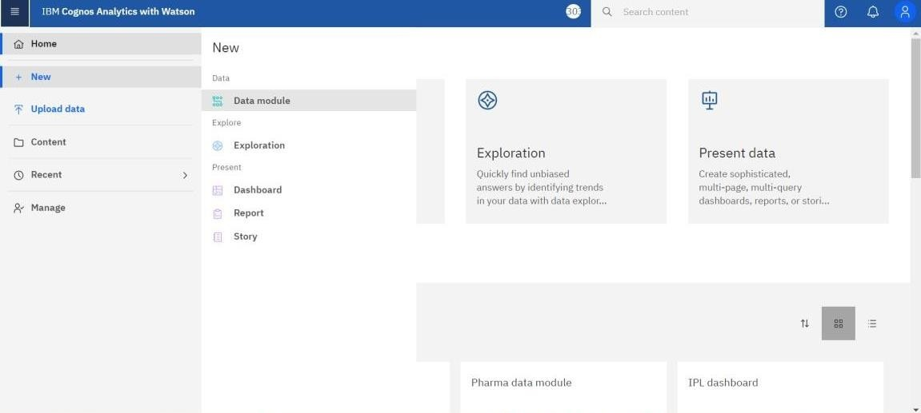

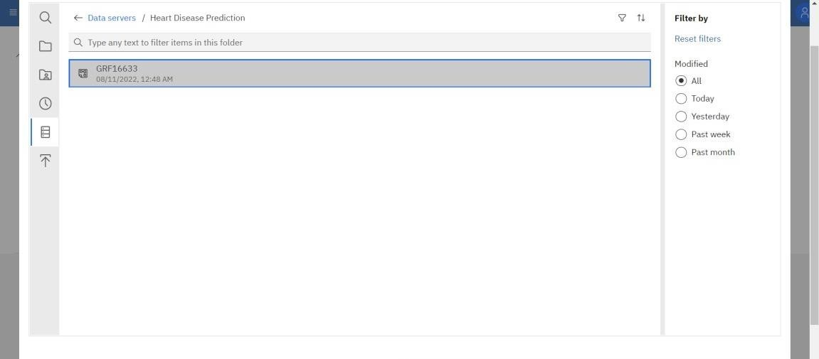

**STEP 3:** Data Module is created successfully.

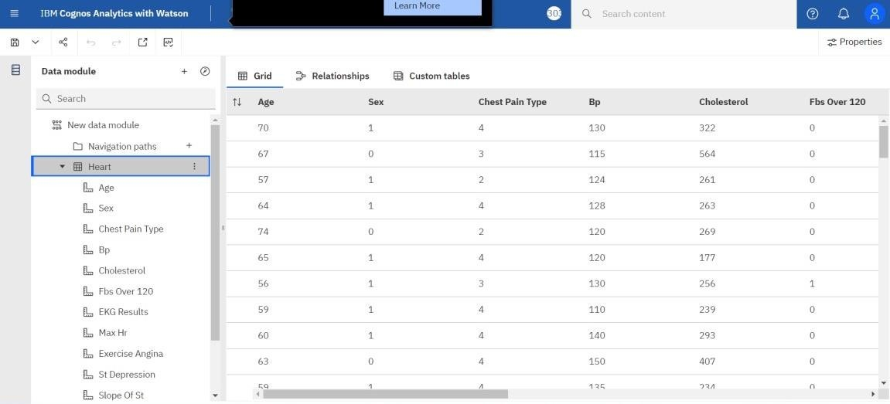

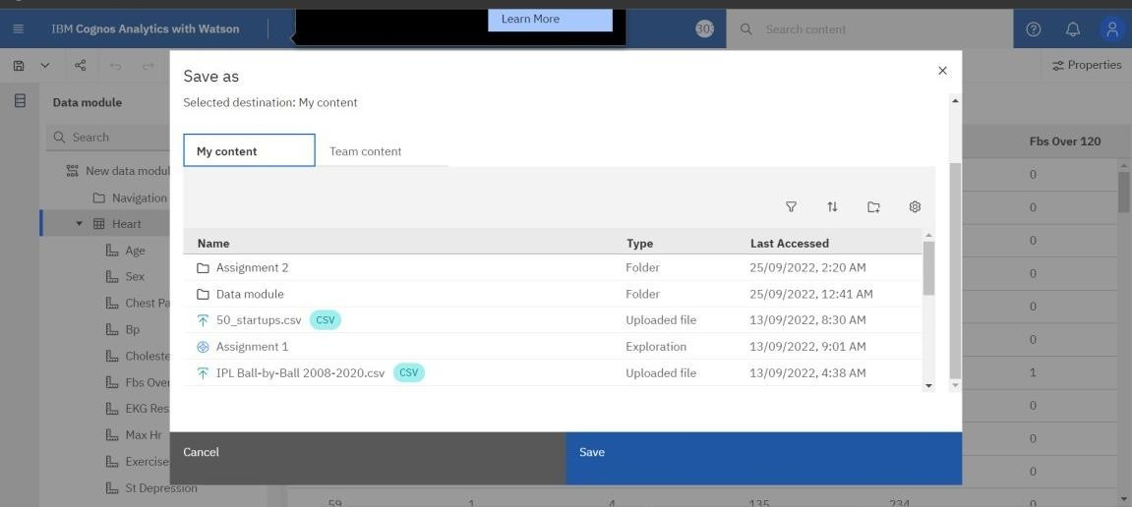

**STEP 5:** Representation of data module with the datum present in Heart Disease Prediction.

